**PROJECT-1**

**1). Create a Resource Group**

**Steps:**

1. Go to [Azure Portal](https://portal.azure.com/)
2. In the left menu, click **Resource groups**
3. Click **+ Create**
4. Set:
   * **Subscription**: Azure subscription 1
   * **Resource Group Name**: AZ_900
   * **Region**: East US
5. Click **Review + create**, then **Create**

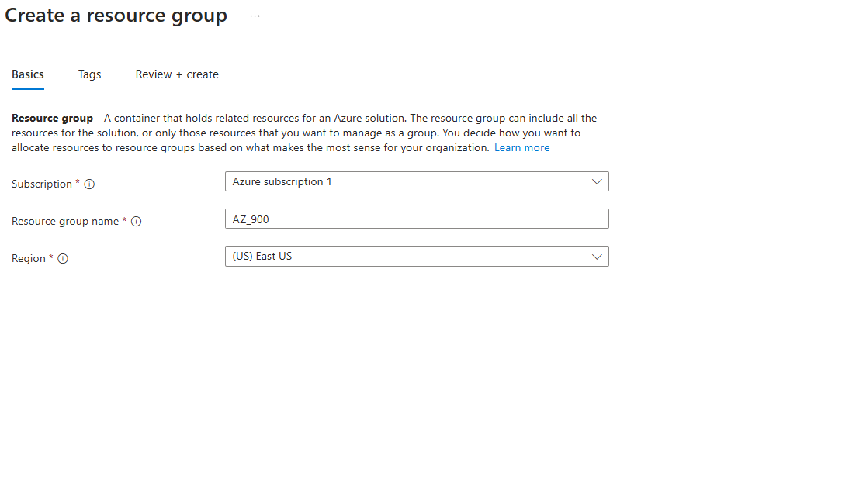

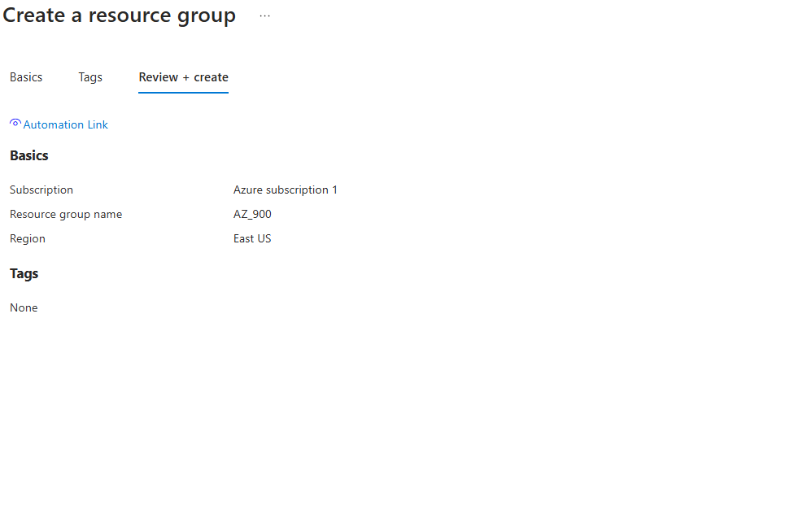

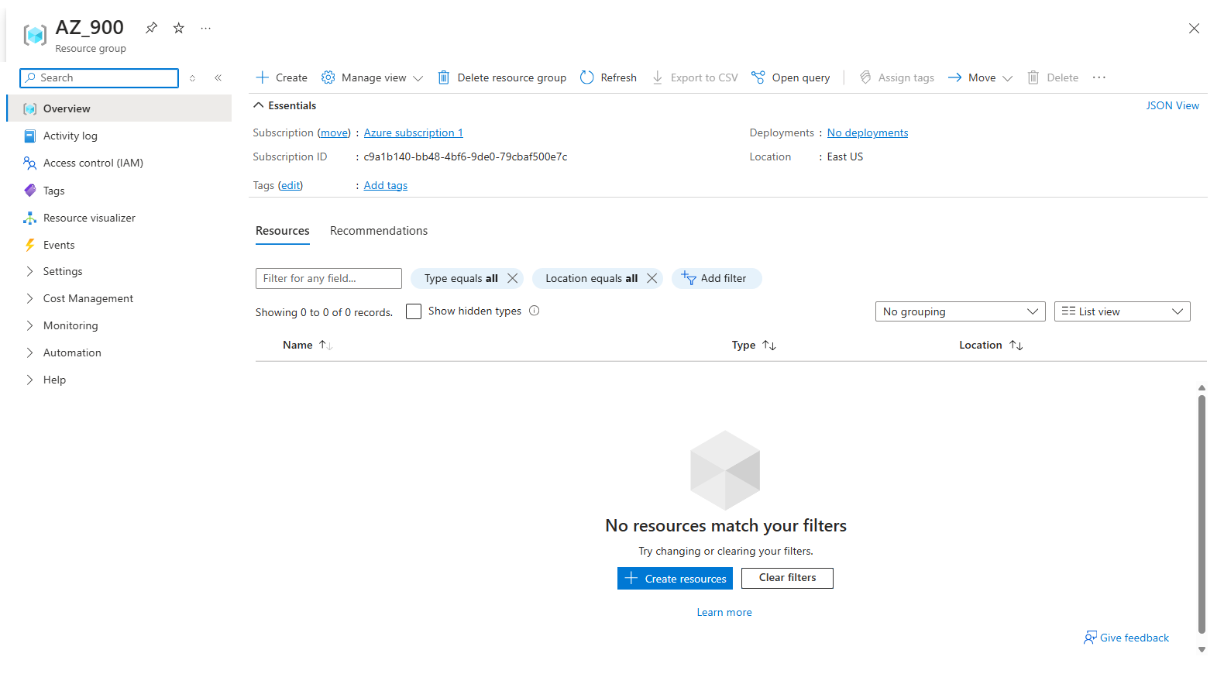

2. Create a Windows Server 2016 Virtual Machine

**Steps:**

1. In the search bar, type **Virtual Machines** and click **+ Create**
2. Select **Azure virtual machine**
3. Under **Basics**:
   * **Subscription**: Azure subscription 1
   * **Resource Group**: Select AZ_900
   * **Virtual machine name**: winserv2016vm
   * **Region**: East US
   * **Availability options**: Leave default
   * **Image**: Choose Windows Server 2016 Datacenter
   * **Size**: Select a basic size like Standard_B1s
   * **Admin username**: azureuser
   * **Password**: Choose a strong password
4. Click **Next: Disks**, choose Standard SSD (default is fine)
5. Click **Next: Networking**, keep default settings (create a new VNet)
6. Click **Review + create**, then click **Create**

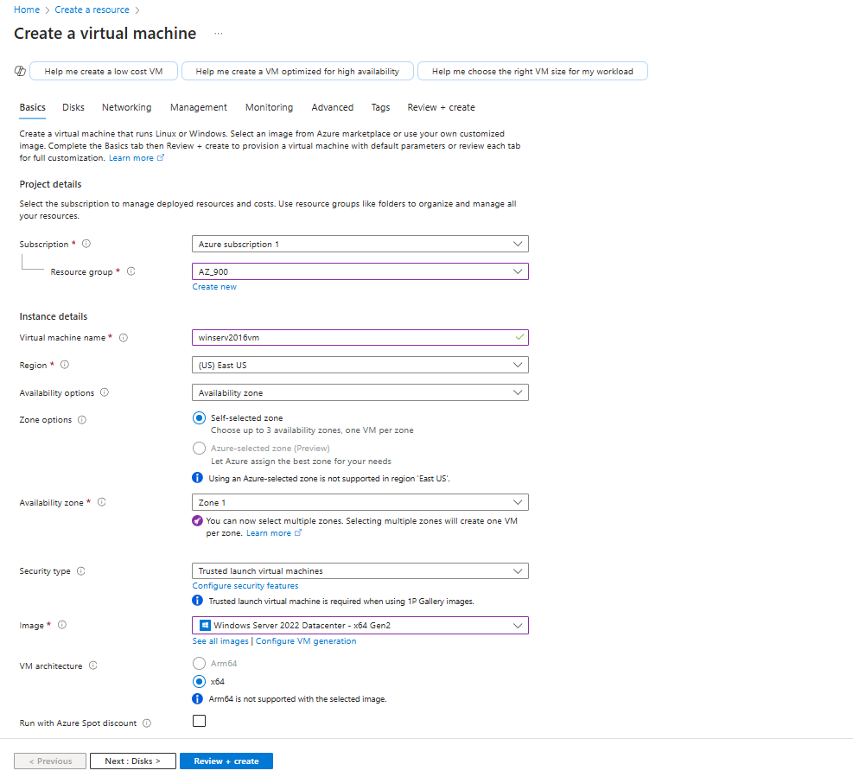

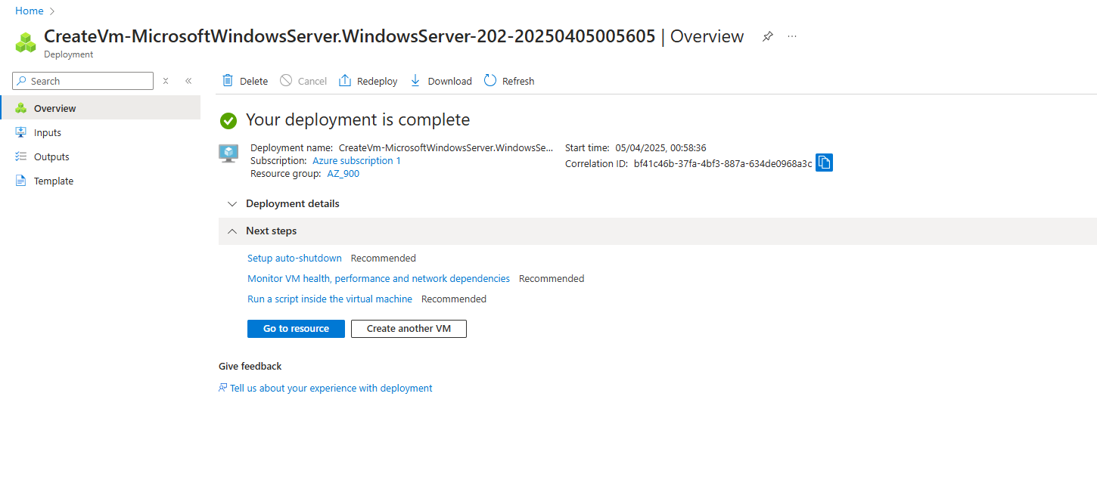



3. Scale up the VM (Change Size)

**Steps:**

1. Go to **Virtual Machines**, select winserv2016vm
2. Click **Size** under **Settings**
3. Browse and select Standard_D2s_v3 or any other higher size
4. Click **Resize**

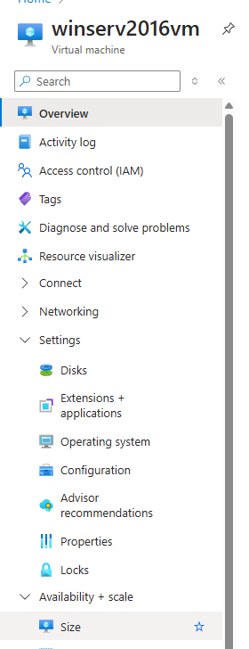

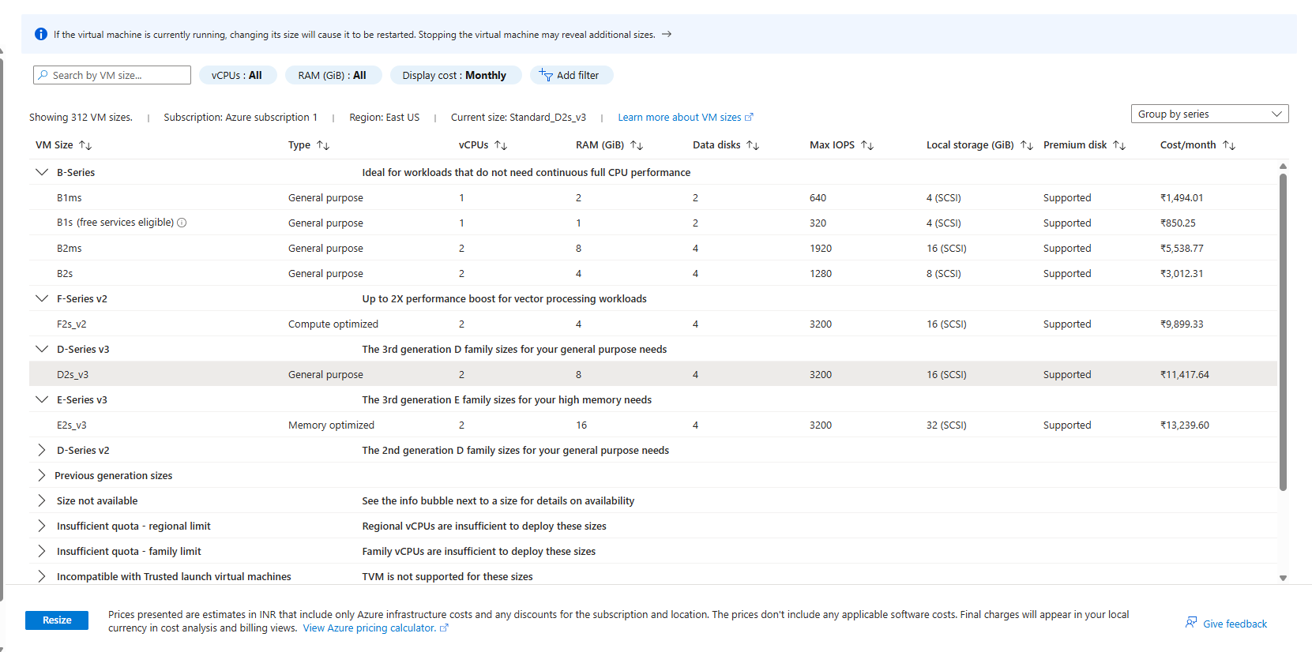

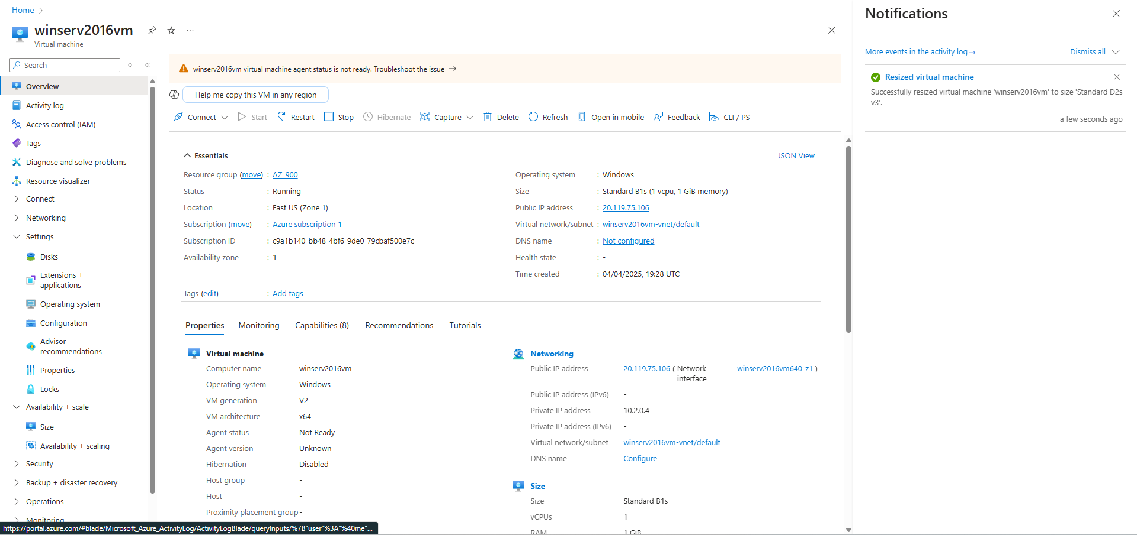

4. Configure Auto Shutdown at 07:00 PM UTC

**Steps:**

1. Go to your VM in Azure
2. In the left pane, click **Operations > Auto-shutdown**
3. Set **Auto-shutdown** to **On**
4. Set the **time** to 07:00 PM UTC
5. Set **notification before shutdown** if needed (optional)
6. Click **Save**

